# SECTION A

**Answer ALL questions.**

# The first two texts are about Space.

**Read Text 1, 'Jodrell Bank Discovery Centre', and answer the questions which follow. Text 1 'Jodrell Bank Discovery Centre'**

**Enjoy a family day out at Jodrell Bank Discovery Centre – whatever the weather we’re sure to inspire you!**

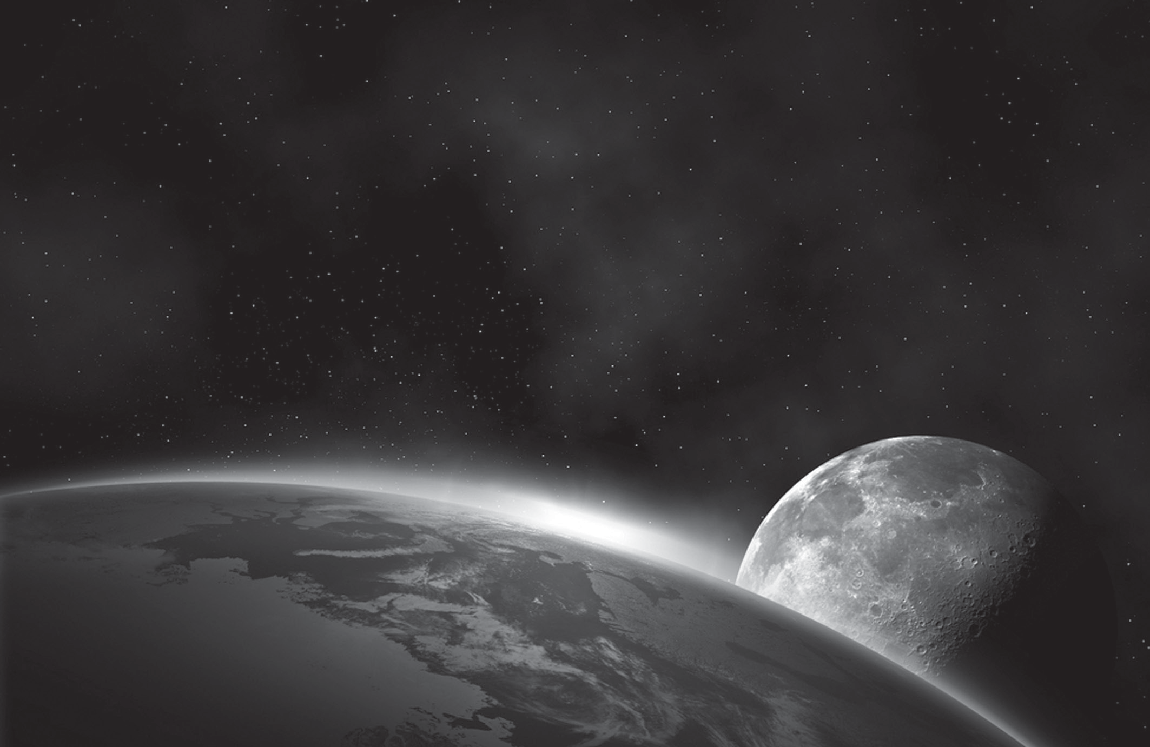

***The Lovell Telescope***: The giant Lovell Telescope is an experience not to be missed! Walk around the telescope pathway to find out about its history and how it works.

You can get a printed souvenir of what the telescope is observing live! 5

Fact! Did you know that the telescope is so sensitive that it could detect the signal from your mobile phone if you were standing on the surface of Mars!

***Space Pavilion****:* What is the telescope observing? How did the Universe begin? What is a black hole?

Come and find answers to the wonders of the Universe, listen to the sounds of the Big 10

Bang and explore the invisible Universe using our interactive exhibit. You can also find out about what astronomers do.

***Planet Pavilion****:* Discover more about our Universe and explore the planets using our model of the Solar System.

How well do you know the planets? Our interactive puzzles will put you to the test! 15

***Gardens****:* We have 35 acres of gardens that families can explore. There are over 2,000 species of trees and shrubs.

An exciting new feature is our Galaxy Garden which has been designed and created by Chris Beardshaw.

It has been built around the themes of Space and Astronomy and creator Chris says, ‘Early 20

scientists like Galileo were inspired and captivated not just by science and their studies of the Universe but by the beauty of nature. Designing and building a garden based on the Galaxy is a great opportunity to explain some of the lessons and themes of astronomy.’

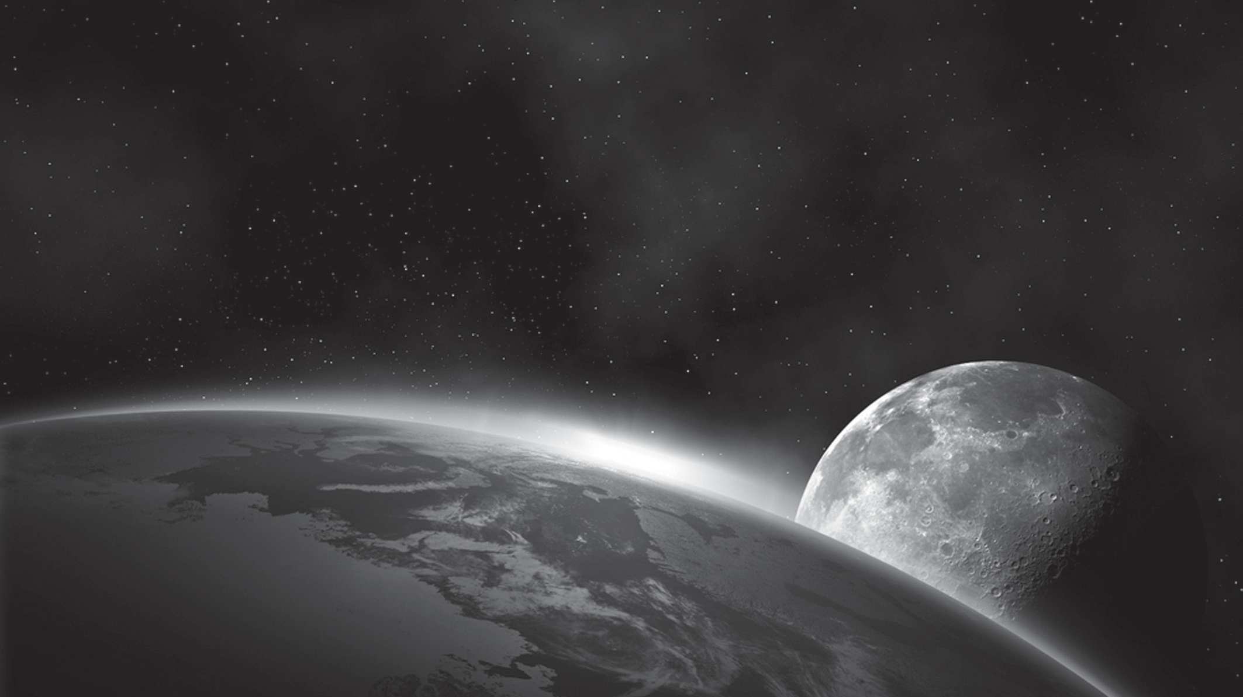

***Facilities****:* Our café is open 10.00am – 4.30pm and welcomes non paying guests.

Gift shop

Outdoor picnic areas Playground

Free parking

**Please help us with our science and turn off all electronic devices whilst on site.**

25

(Source: Taken from a leaflet for the Jodrell Bank Discovery Centre)

# Questions 1, 2 and 3 must be answered with a cross in a box . If you change your mind about an answer, put a line through the box and then mark your new answer with a cross .

1. The main purpose of this text is to:

**A** persuade readers to visit the centre **B** inform readers about the telescope **C** tell readers about the Galaxy Garden

**D** encourage readers to become astronomers

# (Total for Question 1 = 1 mark)

1. Which of the following most accurately describes what inspired early scientists?

**A** science and the stars **B** the Sun and the Moon **C** science and nature

**D** the Galaxy and the Universe

# (Total for Question 2 = 1 mark)

1. Which **one** of the following statements about the Jodrell Bank Discovery Centre is true?
   1. There are over 3,500 species of trees and shrubs.
   2. You can explore the planets using a model of the Solar System.
   3. The Galaxy Gardens are only open to adults.
   4. You can speak to astronomers about their work at the centre.

# (Total for Question 3 = 1 mark)

1. State **two** examples to show that the Lovell Telescope is extraordinary

1 .............................................................................................................................. ............................................................................................................................... ..................

............................................................................................................................... ............................................................................................................................... ......................

2 .............................................................................................................................. ............................................................................................................................... ..................

............................................................................................................................... ............................................................................................................................... ......................

# (Total for Question 4 = 2 marks)

**BLANK PAGE**

# Read text 2, 'The golden age of astronomy', and answer the questions which follow. Text 2 'The golden age of astronomy'

Look upward on a dark, clear night and you will see stars – hundreds of them, even thousands if you are lucky enough to live away from the light pollution of our modern cities. The heavens seem to be ablaze. Many people today know that these tiny, twinkling points of light are suns – many of them far larger, hotter and more powerful

than our own Sun; so much so that the Earth seems less important in the wide Universe 5

than a single grain of sand in the Sahara.

There is still much we do not know, and perhaps may never know, but we have come a long way since our ancestors gazed up towards the stars, just as we do today, and

wondered what they were. Astronomers can now peer into the depths of space, pick up

light from star-systems unbelievably far away, and even send machines to other worlds. 10

We are living in a golden age of astronomy. New observational instruments such as the Hubble Space Telescope, which orbits the Earth beyond the haze of our atmosphere, would have been unimaginable only a few decades ago. Another factor which has been crucial in the amazing advances of the last fifty years is the increase in computer power

available to scientists. 15

(Source: Taken from *Bang! A complete history of the Universe*, by Brian May, Chris Lintott and Patrick Moore.)

# Questions 5, 6 and 7 must be answered with a cross in a box . If you change your mind about an answer, put a line through the box and then mark your new answer with a cross .

1. The main purpose of this text is to:

**A** describe the Hubble Space Telescope **B** inform the reader about star systems **C** tell the reader about space travel

**D** show how astronomy has progressed

# (Total for Question 5 = 1 mark)

1. In paragraph 1, the author tells us that the Earth appears:
2. beautiful
3. polluted
4. insignificant
5. bright

# (Total for Question 6 = 1 mark)

1. According to Text 2, which **one** of the following statements is true:

**A** Light from cities makes it difficult to see the stars. **B** Our Sun is the largest and hottest in the Universe. **C** The Hubble Space Telescope orbits the Sun.

**D** Computers are essential to observe the stars.

# (Total for Question 7 = 1 mark)

1. State **two** things have contributed to the ‘golden age of astronomy’

1 .............................................................................................................................. ............................................................................................................................... ..................

............................................................................................................................... ............................................................................................................................... ......................

2 .............................................................................................................................. ............................................................................................................................... ..................

............................................................................................................................... ............................................................................................................................... ......................

# (Total for Question 8 = 2 marks)

1. Both text 1 and text 2 are about astronomy.

Explain how **both** texts try to interest the reader in astronomy.Wich phrases support the same.

............................................................................................................................... ............................................................................................................................... ......................

............................................................................................................................... ............................................................................................................................... ......................

............................................................................................................................... ............................................................................................................................... ......................

............................................................................................................................... ............................................................................................................................... ......................

............................................................................................................................... ............................................................................................................................... ......................

............................................................................................................................... ............................................................................................................................... ......................

............................................................................................................................... ............................................................................................................................... ......................

............................................................................................................................... ............................................................................................................................... ......................

............................................................................................................................... ............................................................................................................................... ......................

............................................................................................................................... ............................................................................................................................... ......................

............................................................................................................................... ............................................................................................................................... ......................

............................................................................................................................... ............................................................................................................................... ......................

............................................................................................................................... ............................................................................................................................... ......................

............................................................................................................................... ............................................................................................................................... ......................

............................................................................................................................... ............................................................................................................................... ......................

............................................................................................................................... ............................................................................................................................... ......................

............................................................................................................................... ............................................................................................................................... ......................

............................................................................................................................... ............................................................................................................................... ......................

............................................................................................................................... ............................................................................................................................... ......................

............................................................................................................................... ............................................................................................................................... ......................

............................................................................................................................... ............................................................................................................................... ......................

# (Total for Question 9 = 5 marks) TOTAL FOR SECTION A = 15 MARKS

**BLANK PAGE**

# SECTION B

**Answer ALL questions.**

# Read text 3, 'The Night Sky', and answer the questions which follow. Text 3 'The Night Sky'

*In this extract, Ellie is on holiday by a lake.*

One hot moonless night after dinner she walked down alone to the wooden pier. It was perfectly still. She looked up at the brilliant spangled sky and found her heart racing.

Without looking down, with only her outstretched hand to guide her, she found a soft patch of grass and laid herself down.

The sky was blazing with stars. There were thousands of them, most twinkling, a few 5

bright and steady. If you looked carefully you could see faint differences in colour. That bright one there, wasn't it bluish?

She felt again for the ground beneath her; it was solid, steady… reassuring. Cautiously she sat up and looked left and right, up and down the long reach of lakefront. She could

see both sides of the water. The world only looks flat, she thought to herself. Really it's 10

round. This is all a big ball… turning in the middle of the sky… once a day. She tried to imagine it spinning, with millions of people glued to it, talking different languages, wearing different clothes, all stuck to the same ball.

If something as big as the Earth turned once a day, it had to be moving ridiculously fast. Everyone she knew must be whirling at an unbelievable speed. She thought she could 15

now actually feel the Earth turn – not just imagine it in her head, but really feel it in the pit of her stomach. It was like descending in a fast elevator. She craned her neck back further, until she could see nothing but black sky and bright stars. She was overtaken by the giddy sense that she had better clutch the clumps of grass on either side of her and

hold on for dear life, or else fall up into the sky, her tiny tumbling body dwarfed by the 20

huge darkened sphere below.

(Source: Extract from *Contact* by Carl Sagan)

# Questions 10, 11 and 12 must be answered with a cross in a box . If you change your mind about an answer, put a line through the box and then mark your new answer with a cross .

1. ‘the brilliant spangled sky’ (line 2) suggests that:
2. the sky was covered in stars
3. the moon was very bright
4. the sky was full of different colours
5. the moon was surrounded by stars

# (Total for Question 10 = 1 mark)

1. ‘She felt again for the ground beneath her’

Which **one** of the following best describes why Ellie feels for the ground?

1. She is terrified.
2. She is unwell.
3. She is confused.
4. She is overwhelmed.

# (Total for Question 11 = 1 mark)

1. Number the following statements in the order they happen in the extract. The first one is done for you.

1 Ellie walks to the pier

Ellie thinks she can feel the earth spinning

Ellie lies down and looks at the stars

Ellie realises the Earth is round, not flat

Ellie thinks about all the different people on the Earth

**(Total for Question 12 = 2 marks)**

1. ‘If something as big as the Earth turned once a day, it had to be moving ridiculously fast’

Identify two **other** words or phrases in the text that suggest the way the earth is moving.

1 .............................................................................................................................. ............................................................................................................................... ..................

............................................................................................................................... ............................................................................................................................... ......................

2 .............................................................................................................................. ............................................................................................................................... ..................

............................................................................................................................... ............................................................................................................................... ......................

**(Total for Question 13 = 2 marks)**

1. State **three** ways the writer suggests that the Earth is big

1 .............................................................................................................................. ............................................................................................................................... ..................

............................................................................................................................... ............................................................................................................................... ......................

2 .............................................................................................................................. ............................................................................................................................... ..................

............................................................................................................................... ............................................................................................................................... ......................

3 .............................................................................................................................. ............................................................................................................................... ..................

............................................................................................................................... ............................................................................................................................... ......................

**(Total for Question 14 = 3 marks)**

1. Explain how the writer shows the build up of Ellie’s feelings.

Support your ideas by referring to words and phrases from the whole text and commenting on them.

............................................................................................................................... ............................................................................................................................... ......................

............................................................................................................................... ............................................................................................................................... ......................

............................................................................................................................... ............................................................................................................................... ......................

............................................................................................................................... ............................................................................................................................... ......................

............................................................................................................................... ............................................................................................................................... ......................

............................................................................................................................... ............................................................................................................................... ......................

............................................................................................................................... ............................................................................................................................... ......................

............................................................................................................................... ............................................................................................................................... ......................

............................................................................................................................... ............................................................................................................................... ......................

............................................................................................................................... ............................................................................................................................... ......................

............................................................................................................................... ............................................................................................................................... ......................

............................................................................................................................... ............................................................................................................................... ......................

............................................................................................................................... ............................................................................................................................... ......................

............................................................................................................................... ............................................................................................................................... ......................

............................................................................................................................... ............................................................................................................................... ......................

............................................................................................................................... ............................................................................................................................... ......................

............................................................................................................................... ............................................................................................................................... ......................

............................................................................................................................... ............................................................................................................................... ......................

............................................................................................................................... ............................................................................................................................... ......................

............................................................................................................................... ............................................................................................................................... ......................

............................................................................................................................... ............................................................................................................................... ......................

............................................................................................................................... ............................................................................................................................... ......................

............................................................................................................................... ............................................................................................................................... ......................

............................................................................................................................... ............................................................................................................................... ......................

............................................................................................................................... ............................................................................................................................... ......................

............................................................................................................................... ............................................................................................................................... ......................

............................................................................................................................... ............................................................................................................................... ......................

............................................................................................................................... ............................................................................................................................... ......................

............................................................................................................................... ............................................................................................................................... ......................

............................................................................................................................... ............................................................................................................................... ......................

**(Total for Question 15 = 6 marks)**

**TOTAL FOR SECTION B = 15 MARKS**

# SECTION C

**Answer both questions.**

# You will be assessed on spelling, punctuation and grammar in both questions.

1. Write an article for a school magazine, telling readers about a hobby or interest you enjoy.

In your writing you should:

Explain what your hobby or interest involves

Describe why you enjoy it

Inform readers about how to get involved.

............................................................................................................................... ............................................................................................................................... ......................

............................................................................................................................... ............................................................................................................................... ......................

............................................................................................................................... ............................................................................................................................... ......................

............................................................................................................................... ............................................................................................................................... ......................

............................................................................................................................... ............................................................................................................................... ......................

............................................................................................................................... ............................................................................................................................... ......................

............................................................................................................................... ............................................................................................................................... ......................

............................................................................................................................... ............................................................................................................................... ......................

............................................................................................................................... ............................................................................................................................... ......................

............................................................................................................................... ............................................................................................................................... ......................

............................................................................................................................... ............................................................................................................................... ......................

............................................................................................................................... ............................................................................................................................... ......................

............................................................................................................................... ............................................................................................................................... ......................

............................................................................................................................... ............................................................................................................................... ......................

............................................................................................................................... ............................................................................................................................... ......................

............................................................................................................................... ............................................................................................................................... ......................

............................................................................................................................... ............................................................................................................................... ......................

**(Total for Question 16 = 15 marks)**

1. In Passage 3, Ellie is very impressed by seeing the stars on a dark night. Describe a place that has impressed you. Use adjectives to describe.

You should include:

Description of what you saw

Why it impressed you

How it made you feel

............................................................................................................................... ............................................................................................................................... ......................

............................................................................................................................... ............................................................................................................................... ......................

............................................................................................................................... ............................................................................................................................... ......................

............................................................................................................................... ............................................................................................................................... ......................

............................................................................................................................... ............................................................................................................................... ......................

............................................................................................................................... ............................................................................................................................... ......................

............................................................................................................................... ............................................................................................................................... ......................

............................................................................................................................... ............................................................................................................................... ......................

............................................................................................................................... ............................................................................................................................... ......................

............................................................................................................................... ............................................................................................................................... ......................

............................................................................................................................... ............................................................................................................................... ......................

............................................................................................................................... ............................................................................................................................... ......................

............................................................................................................................... ............................................................................................................................... ......................

............................................................................................................................... ............................................................................................................................... ......................

............................................................................................................................... ............................................................................................................................... ......................

............................................................................................................................... ............................................................................................................................... ......................

............................................................................................................................... ............................................................................................................................... ......................

............................................................................................................................... ............................................................................................................................... ......................

**(Total for Question 17 = 15 marks)**

**TOTAL FOR SECTION C = 30 MARKS TOTAL FOR PAPER = 60 MARKS**

**15**

# BLANK PAGE